Reliable data transfer protocols

RTT
Round trip time. Time required for a packet to reach destination and its ACK to get back. Transmission time is not a part of RTT.

Positive acknowledgments
Control messages of reliable data transfer protocols which say “OK” and acknowledge a error-free delivery which was expected. They silently discard an erroneous transmission. In this case the sender maintains a timer to time out and and retransmits.

Negative acknowledgments
Control messages of reliable data transfer protocols that say “Please repeat that(Because what I received was in error)”.

Cumulative acknowledgment
Acknowledgments which acknowledge all previous packets

What do RDT protocols seek to address?
- Good throughput
  - By making use of pipelining.
- Reliable delivery
  - In-order delivery
    - Taking care of reordered packets and acknowledgments during propagation
  - Guaranteed delivery
    - Taking care of packet and acknowledgments that get lost.
  - Error-free delivery
    - Taking care of of packets whose integrity may have been compromised. This is taken care of ??????

Stop-and-wait protocol?
It is a protocol where the sender transmits the next packet only when it is sure that the receiver has received the previous packet

Efficiency of a communication channel in a stop-and-wait-protocol
Efficiency =
=
=

Alternating bit protocol
A protocol where only one bit and hence only two numbers, 0 and 1, are used as sequence numbers. Because alternating bit protocol have to operate in a stop-and-wait fashion, the sequence numbers of the packets alternate. Hence the name.

Main disadvantage with stop and wait protocols
Low performance. Most of the time is spent waiting for acknowledgments. Solution is to use pipelining.

Consequences of using pipelining in RDT protocols
- Range of sequence numbers must be increased since there may be multiple, in-transit, unacknowledged packets
- The sender and possibly the receiver(depending on the design of the RDT protocol) may have to buffer more than one packet
  - The sender has to buffer sent but unacknowledged packets.
  - The receiver may have to buffer out-of-order delivered packets.

Basic approaches towards pipelined error recovery.
- Go-Back-N
- Selective repeat

Need for sequential numbers in a reliable data transfer protocol?
So that a receiver can construct distinguishable acknowledgment's. If the ack's are not distinguishable a sender will not know if his packet was received or lost.

How can the window length of a sliding window protocol calculated?
The length of the window is the number of packets that can be transmitted in the time-period equal to a single round trip delay when the acknowledgment of the first packet sent is received.

Efficiency of a communication channel in a sliding window protocol
Efficiency =
=
=

Window sizes of sender and receiver when n bits are used to represent the window
Protocol | Sender window size | Receiver window size
Go-Back-N | 2^{n} - 1 | 1
Selective repeat | 2^{n-1} | 2^{n-1}

What care should be taken while designing a reliable data transfer protocol with a finite sequence number space?
- In a finite sequence number space, the receiver window can wrap around the finite space and there is a possibility of its window's leading edge overlapping with the senders windows trailing edge.
- When this happens
  - The receiver might accept an out of order packet and assume that it is an in-order packet as the expected sequence number for both will be the same.
  - The receiver may re-accept packet 'k' of the last window instead of discarding it as a duplicate.

Why does the above happen?
Happens when receivers window moves out of sync with the senders window due to lost or delayed ack's.
Window size - Go-Back-N
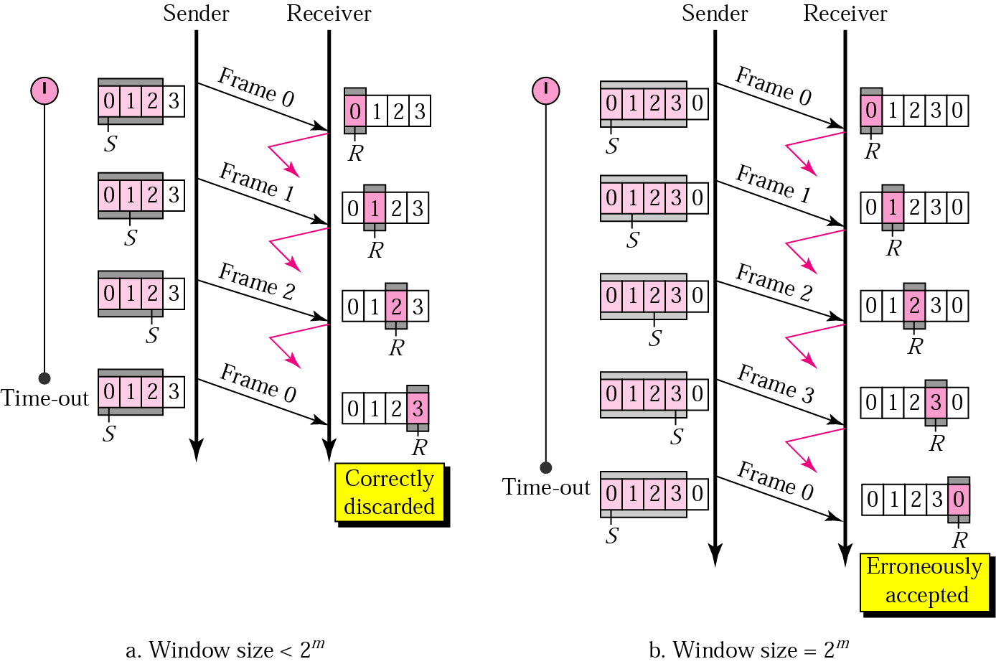

Window size – Selective repeat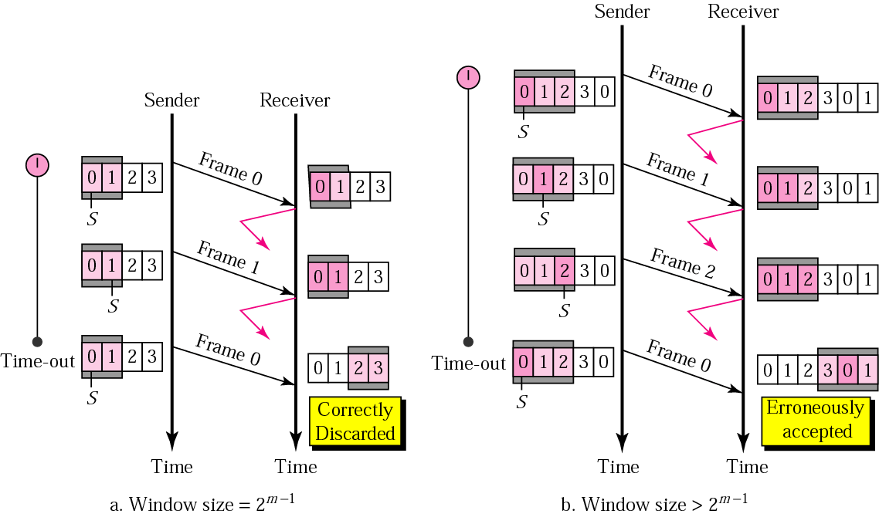

Throughput of a sliding window protocol(Illustration)
- sender and receiver window = n segments with b bits in each segment
- T_{trans} = Time to transmit of 1 segment(b bits)
- T_{prop} = Time for a signal to propagate from the sender to the receiver

Time spent by the receiver waiting for 1st segment = T_{prop}
Time in which n segments are received by the receiver = n T_{trans}
Time spent by the receiver waiting for the 1st segment of the next window =
Time for the 1st ACK to reach the sender
– Time in which the receiver receives the n-1 packets of the 1st window
+ Time to receive the 1st segment of the next window
= T_{prop} – (n-1)T_{trans} + T_{prop}

